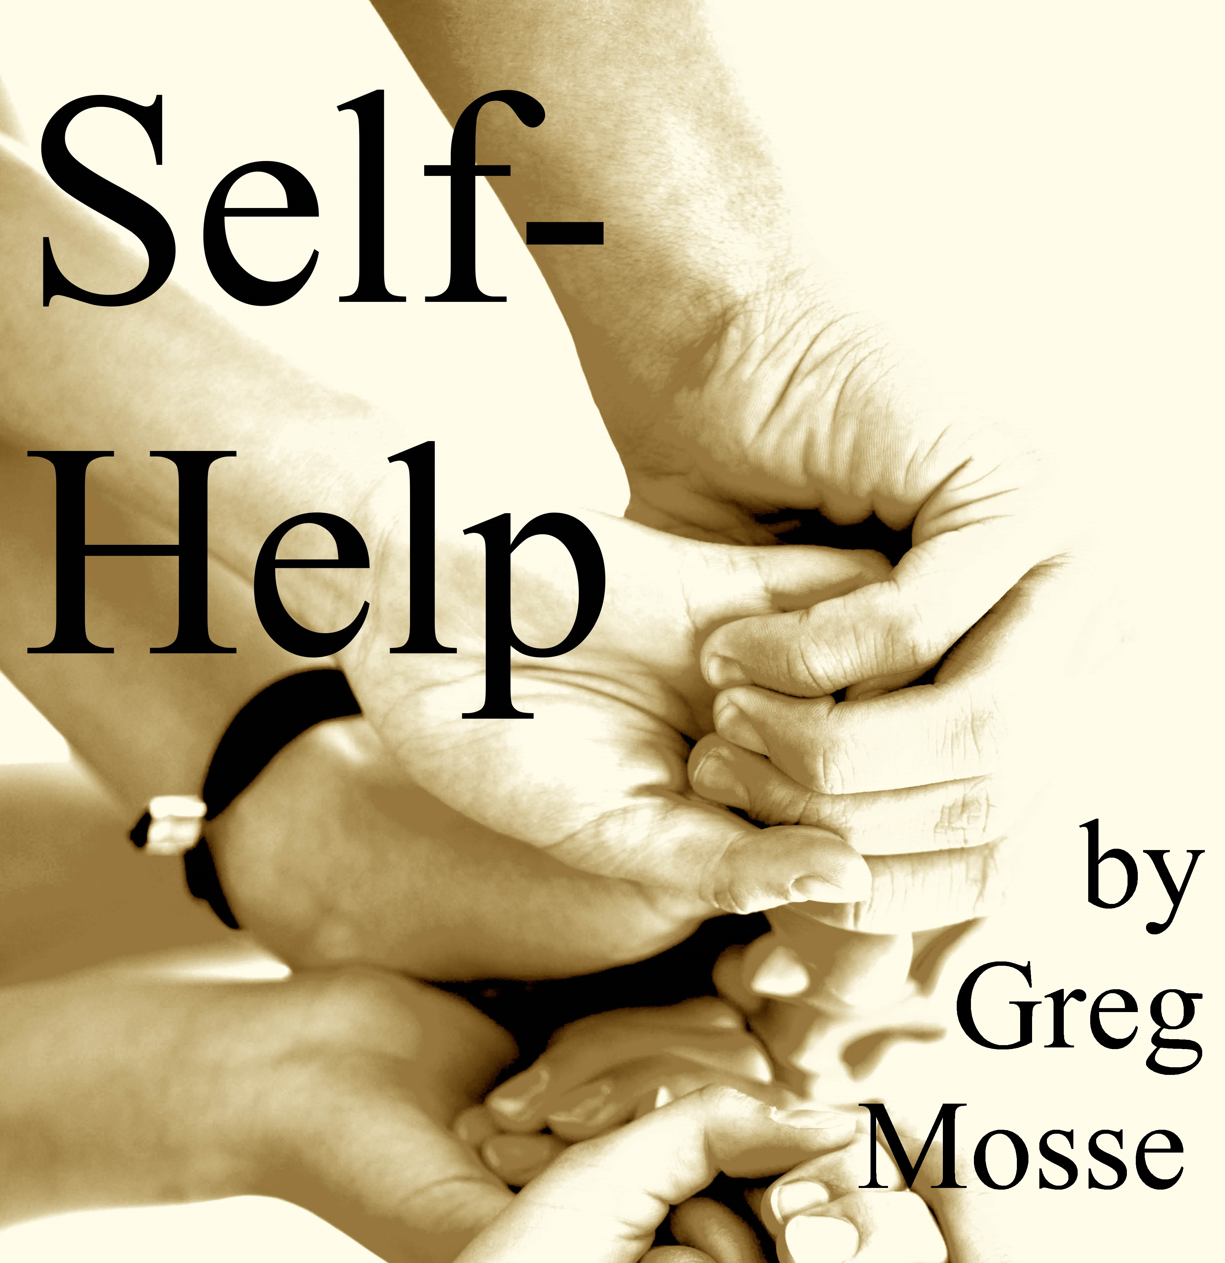
Self-Help is a comedy full of surprising twists about five young people who are trying to escape from living on the streets of London. Nothing comes easy but, in the end, they pull together – helping themselves to new lives.

Greg wrote the play specifically for young actors and he is thrilled that it is being directed by Jack Northeast of Chichester Festival Youth Theatre.

Performances
Saturday, 20 June 2015, 2pm
Sunday, 21 June 2015, 2pm.
Wednesday, 24 June 2015, 2pm.

Venue
St John’s Chapel

Ticket price
£ 5

Contact
Greg Mosse
gregmosse@gmail.com
07973 641 503

